Mental Actions

🔹 What is Mental Actions
# Source: AI Source: Provided by: [Data Path: Persons Table -> ID Column: 1, Name_En Column: Motasem Essam] -> From: [Chatgpt (GPT-4-turbo)] on [7/27/2025]
Mental action verbs are verbs that describe activities that happen in the mind. These actions cannot be seen physically — they show thinking, feeling, knowing, or deciding.

✅ Definition:
# Source: AI Source: Provided by: [Data Path: Persons Table -> ID Column: 1, Name_En Column: Motasem Essam] -> From: [Chatgpt (GPT-4-turbo)] on [7/27/2025]
A mental action verb expresses something that happens internally — in your mind or emotions — rather than through physical movement.

🧠 Key Idea:
# Source: AI Source: Provided by: [Data Path: Persons Table -> ID Column: 1, Name_En Column: Motasem Essam] -> From: [Chatgpt (GPT-4-turbo)] on [7/27/2025]
You can’t see someone doing these actions, but they are still actions because they involve mental effort.

📚 Examples of Mental Action Verbs:
# Source: AI Source: Provided by: [Data Path: Persons Table -> ID Column: 1, Name_En Column: Motasem Essam] -> From: [Chatgpt (GPT-4-turbo)] on [7/27/2025]
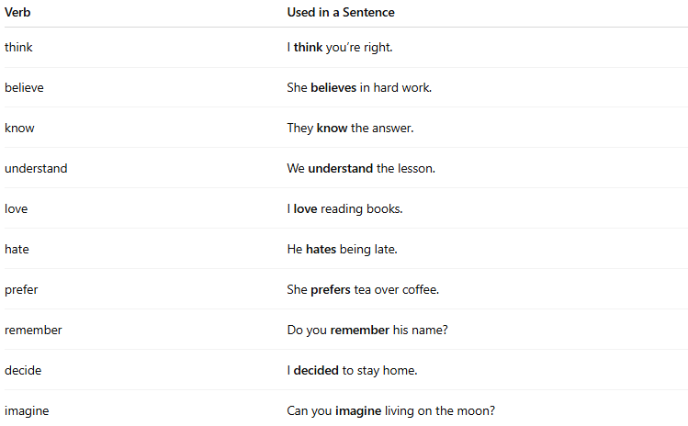
Verb | Used in a Sentence
think | I think you’re right.
believe | She believes in hard work.
know | They know the answer.
understand | We understand the lesson.
love | I love reading books.
hate | He hates being late.
prefer | She prefers tea over coffee.
remember | Do you remember his name?
decide | I decided to stay home.
imagine | Can you imagine living on the moon?

🔁 Mental vs Physical Action Verbs:
# Source: AI Source: Provided by: [Data Path: Persons Table -> ID Column: 1, Name_En Column: Motasem Essam] -> From: [Chatgpt (GPT-4-turbo)] on [7/27/2025]
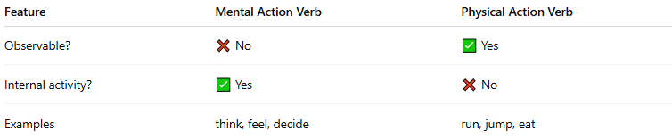
Feature | Mental Action Verb | Physical Action Verb
Observable? | ❌ No | ✅ Yes
Internal activity? | ✅ Yes | ❌ No
Examples | think, feel, decide | run, jump, eat

✅ Summary:
# Source: AI Source: Provided by: [Data Path: Persons Table -> ID Column: 1, Name_En Column: Motasem Essam] -> From: [Chatgpt (GPT-4-turbo)] on [7/27/2025]
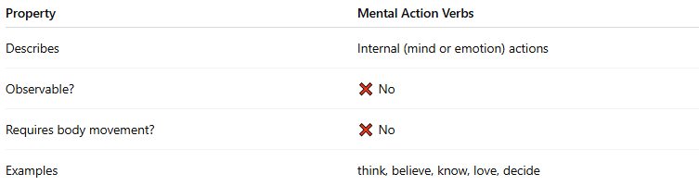
Property | Mental Action Verbs
Describes | Internal (mind or emotion) actions
Observable? | ❌ No
Requires body movement? | ❌ No
Examples | think, believe, know, love, decide

